Radiance Comparison Temperature Method
The InfraScope Software includes a means, the Radiance Comparison Temperature method, to measure temperatures without computing emissivity. In this technique, the sample being tested serves as a calibration source, whatever its many pixel emissivities. The user captures a sequence of 11 unpowered radiance images at sequentially increasing stage temperatures. For any given region of interest, this generates a calibration curve of radiance vs. temperature that is independent of the local emissivity. The algorithm then compares the local radiance of the powered device, to the unpowered radiance curve.
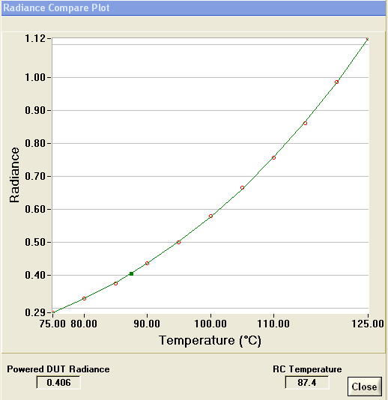 | 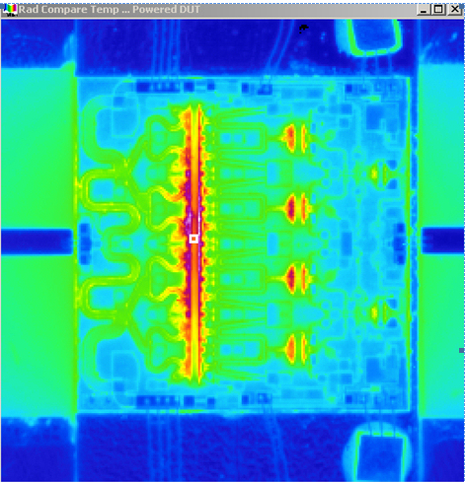
Note the region of interest (ROI) box in the right image. The plot at the left gives the radiance just in that ROI for each of 11 unpowered captures. Then the user captures a radiance image with the device powered. The Radiance Compare algorithm compares the powered radiance to the curve and estimates a powered temperature, seen in the graph as 87.4°C. This method does not require finding the material emissivity. As such, it works even if the emissivity is non-constant over temperature.

The Radiance Compare Temperature (RCT) method has some powerful attraction but it has serious disadvantages to consider as well.
- The temperature spread should be selected to be as narrow as possible to minimize sample expansion and contraction. We typically use a 10º Celsius spread. Often the expansion is still a problem.
- It takes time to adjust the stage through 12 or effectively 13 different temperatures. This is a slow technique and more suited to confirming results than making production measurements.
- The RCT works best when interpolating, rather than extrapolating, so the chosen temperature spread should ideally sandwich the expected powered temperature. Sometimes this isn’t possible, but it should be attempted.

RCT Procedure
- Preparation:
  - The RCT measurement takes 30 to 40 minutes. Some advance preparation may prevent having to repeat a measurement that failed for lack of planning.
  - Know the limits of your thermal stage. If your RCT settings try to drive the thermal stage above its maximum set point the measurement will fail at the last few frames. Most QFI supplied 2” stages reach a maximum of 140C and stabilization time is long near the maximum temperature. QFI supplied 4” stages vary in maximum temperature depending on the model. Check first to save a lot of time later.
  - Choose a suitable camera Temp Range before beginning. All of the RCT data must be collected at a single range. Make sure that your sample doesn’t saturate the camera range when unpowered at the last RCT Stop temperature and make sure your sample doesn’t saturate the camera when powered at the selected operating temperature.
- Start by measuring the sample temperature in a defined region of interest by the normal means. Try to select the RCT start and step temperatures to include that measured temperature. This method works for extrapolated results (operating radiance outside the collected unpowered radiances) but it is always better to interpolate to find the temperature if you can.
- Open the Radiance Compare from the Rad Comp Tab and open the Temp Stage Tab just above it as seen here.

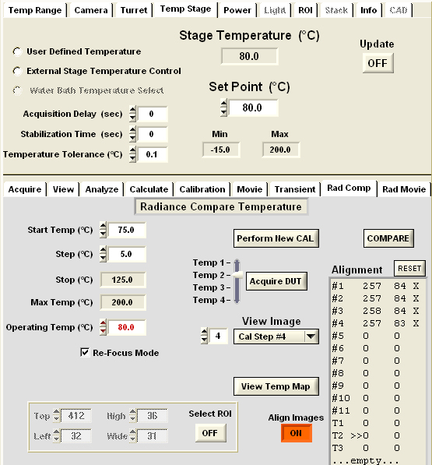

- On the Rad Comp Tab create the temperature spread by entering a Start Temp and Step temp for 11 measurements. We recommend making the step 5°C (50°C spread). Try to make the value found in step 2 fall between the Start Temp and the Stop Temp.
- Enter an Operating Temperature. Use the stage temperature from step 1. At the end of the unpowered sequence the software will set the stage to the Operating Temperature and prompt you to power the device.
- Check the box for refocus mode. This lets you compensate for thermal expansion of your sample. When Refocus Mode is selected the software will pause before each measurement after the stage has stabilized at the new, higher temperature. The pause allows you to re-center and refocus the image to compensate for thermal movement and expansion.
- On the Temp Stage Tab set the Acquisition Delay to 10s, the Stabilization Time to 10s and the Temperature Tolerance to 0.2°C. During the measurement when the software adjusts the stage temperature, the software will not acquire an image unless the stage has remained within the Temperature Tolerance for the period specified in the Stabilization Time. When that is successful then the software will still add the Acquisition Delay time before capturing an image. The idea is for the sample to be thermally stable. If the Temperature Tolerance is too tight or the Stabilization Time too long then the sequence will take a painful amount of time to complete. If those values are too loose then the results may be too imprecise. Some experimentation around the values just given will show the right values for your sample as measured in your lab.
- Be sure the device is powered off and start the acquisition by pressing “Perform New Cal”. The instrument will begin collecting the data set.
- When the unpowered set is finished, select “Acquire DUT”.

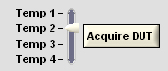

- When the Software prompts for the powered temperature, before applying power, check the focus, centering and the goodness of the curve displayed from the radiance collection.
- Just like the standard method, you may acquire up to 4 powered images by choosing Temp 1 through Temp 4.
- To get the results, define a Region of Interest from the ROI Tab if you haven’t already and press the Compare button. The temperature of the ROI appears just below the graph.
- Up until now all of the displayed images have been radiance images. To see a temperature map based on this method press View Temperature Map. This computation takes some time. The software will perform the RCT Compare interpolation on each pixel in the entire image to create the final temperature map.
- When finished, save the RCT as an RCT file from the File menu. (RCT Movie is in development and will not be discussed here).

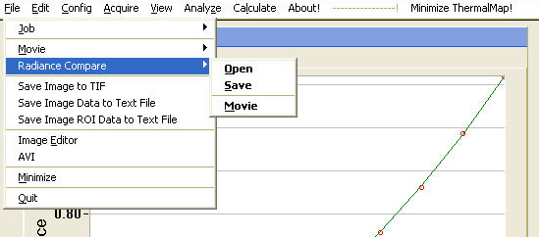

Compensating for Thermal movement or expansion
The RCT method requires changing the thermal stage temperature over 20° or 50°C or more, enough so that most ICs and the sample mounting structures will suffer thermal movement and thermal expansion. That movement including defocus will spoil the results. The RCT software provides two methods to compensate for thermal motion.
- The preferred method is described above, in which the user checks the re-focus mode option and the software pauses after each thermal stage change to let the user re-center and refocus. This is simple and effective and includes refocus for focus-height changes of the sample.
- The older post acquisition alignment method allows the user to map the offset on previously acquired images in X-Y only. If the sample suffered focus drift during the measurement there is nothing to be done about it. But the method does help to analyze previously captured data.

Post Acquisition Re-alignment method

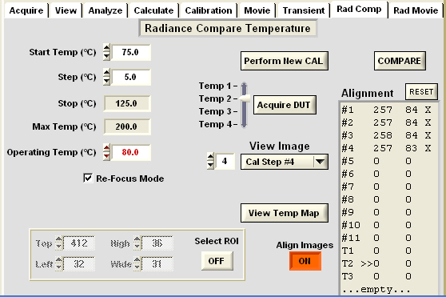

Reason: after collecting RCT data or loading previously stored RCT data we realize that thermal movement has caused the ROI to shift through the collected images. This method relocates the ROI box over each image frame to compensate after the fact for thermal movement.

- Reset the values if any, in the alignment box.
- Activate the “Align Images” button.
- Use the View Image pull down or scroll buttons to choose and display the first image.
- Click once in the image on an easily recognized fiducial point, such as a corner where two metal lines join. You will see the coordinates appear in the Alignment window.
- Advance to the next image and repeat for all image frames.
- When finished with the alignment, choose the Select ROI button.
- Use the mouse to define a box Region of Interest.
- Press the Compare button to find the temperature in that ROI displayed just under the graph.

Black Paint - Sample painting
At QFI we love our 1-temp emissivity compensation and we use our standard method with confidence and with considerable preference over any other technique. However there are some thermal mapping measurements that call for a bit of black paint. Examples are:
- Samples that may not be heated above ambient.
- Samples that exhibit transparency or partial transparency in areas that require an accurate measurement.
- Any sample that makes you suspicious that the measurement may not be quite right.
- Powered samples that show considerable, discontinuous differences in temperature between adjacent areas with starkly different emissivities.

There are other examples, and we don't routinely paint samples, but painting a single example of a device can give a good deal of confidence that subsequent unpainted samples are yielding the right measurement. Even if you have flight hardware, you may want to acquire a single sacrificial part to validate your measurements. Painting a sample is an acquired skill. Here we simply offer some tips about how we have done it.

- It doesn't take much paint. Less is better. As little as 30% emissivity can yield a pretty good measurement. That would be so little paint that you can still see features of the IC.
- We use an inexpensive flat black spray paint from the local hardware store. There are very expensive commercially prepared black paints for infrared applications but we find that we get very good results with the hardware store variety. As in the bullet above, in many cases it only takes about 30% emissivity to make a good measurement.
- Paint the sample on a bit of cardboard out in the parking lot. Your facilities manager will appreciate your discretion.
- Paint lightly from a few feet away. The paint shouldn't flow. It should be nearly dry as it lands on the sample.
- We have tried spinning on the paint, and using air brushes. Sometimes we like these techniques, but we also like the simpler method of carefully wielding the spray paint can.
- Bake the paint. Sometimes we use an oven. Sometimes we bake the paint with a hot air gun. If you leave solvent you may get short circuits and the heat that you measure will be an artifact.
- Sometimes, after a measurement, you can wash off most of the paint with acetone for a subsequent unpainted measurement.

2-Temperature Emissivity Method
Note: This technique is tedious by its nature. We generally prefer painting a device before resorting to the 2-temperature method.

At each pixel the InfraScope TM makes a very shrewd approximation of material emissivity with our proprietary 1-temp emissivity computation. This technique is fast and accurate and it avoids sample expansion and contraction from changing the thermal stage. However the 1-temp technique requires an elevated sample temperature. It works best when the sample area has an emissivity-temperature product that exceeds 25° Celsius (e.g., 50% emissivity at 50° C). We recommend making all thermal map measurements with unpowered sample temperatures of 70° C to 90° C. Sometimes some samples in some setups just cannot be mounted at elevated temperatures. The InfraScope TM offers a 2-temperature emissivity method for such samples. It is a reliable way to obtain emissivities but it has drawbacks. Chief among the drawbacks is thermal expansion of the sample. The two measurements should be separated by 15° or 20° Celsius for good signal to noise, but that separation of stage temperature will cause the sample and the thermal stage and other mounting hardware to expand over microns. This movement between the two measurments will often spoil the emissivity map at every metal edge or other emissivity transition area. Nevertheless for relatively large areas the technique measures emissivity well. The 2-temp method is also time consuming and tedious because you must wait for the thermal stage to change temperature and to stabilize at the new temperature. It is virtually always preferable to work with the standard 1-temp emissivity algorithm. For more information about 2 temperature emissivity mapping, see Microthermal Imaging in the InfraRed in Technical Publications at www.quantumfocus.com. If you want to make a 2-temperature measurement, here is how it is done.

One measurement at T1 is stored in memory as R_{a} for radiance 'a', the 2nd measurement at a second temperature is stored as R_{b}. These data can be collected manually with the Acquire pull down menu and the emissivity can be computed with the Calculate pull down menu as seen here.

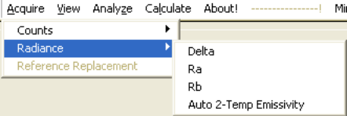 | 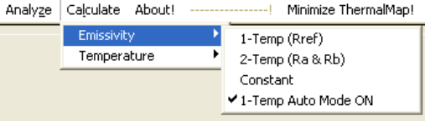
Access 2-temp emissivity correction from the Acquire Radiance menu and calculate
And employ the emissivity from the Calculate menu.

If you wish to make many such measurements for a particular study, it is more convenient to set up the parameters in user.def, accessed from the Edit pull down menu.

User.def setup for automated 2-temp emissivity measurement.
; Ra / Rb Auto 2-Temp Emissivity Parameters
AutoEmisTempA=60.0
AutoEmisTempB=80.0

AutoEmisDelaySecA=5
AutoEmisDelaySecB=5

AutoEmisRangeA=1
AutoEmisRangeB=1

AutoEmisFramesA=25
AutoEmisFramesB=25

In user.def set the desired two temperatures as shown above. Set the delay variables from 5 to 20 seconds as a suitable delay for the thermal stage to stabilize after it has reached the desired temperature. (Be sure to set non-zero values in the Temp Stage Tab for stabilization time and for temperature tolerance. A zero value tells the software not to wait for the stage to reach temperature.) Choose the appropriate range for the two unpowered radiance collections. The powered measurement will be taken at the 2nd of the two ranges and also at the second thermal stage temperature. You may add frames of averaging if desired.

When the setup is complete, save user.def. Launch the automated 2-temp measurement with the Acquire Radiance pull down menu.

